TD 1 et 2 – GIT PYTHON
Ruben Salaün
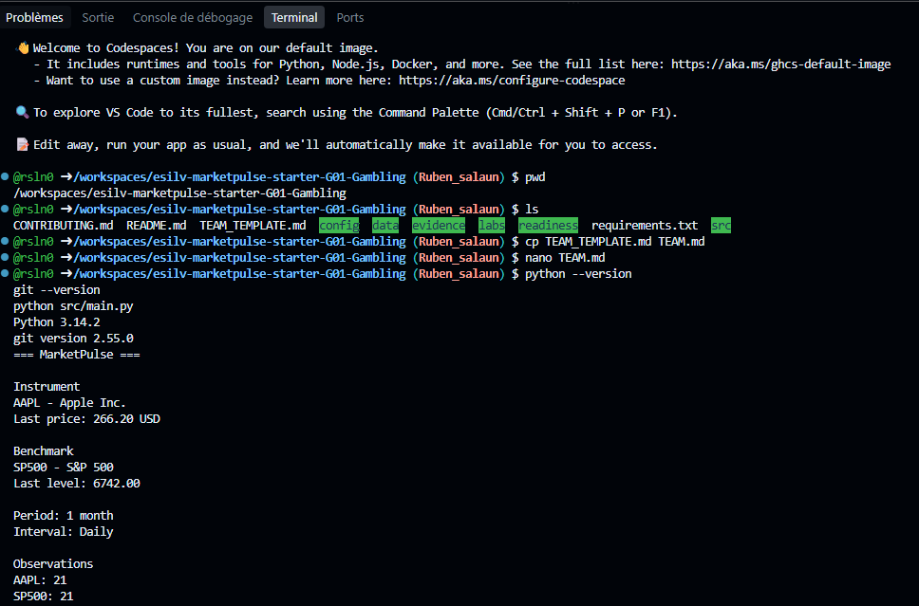
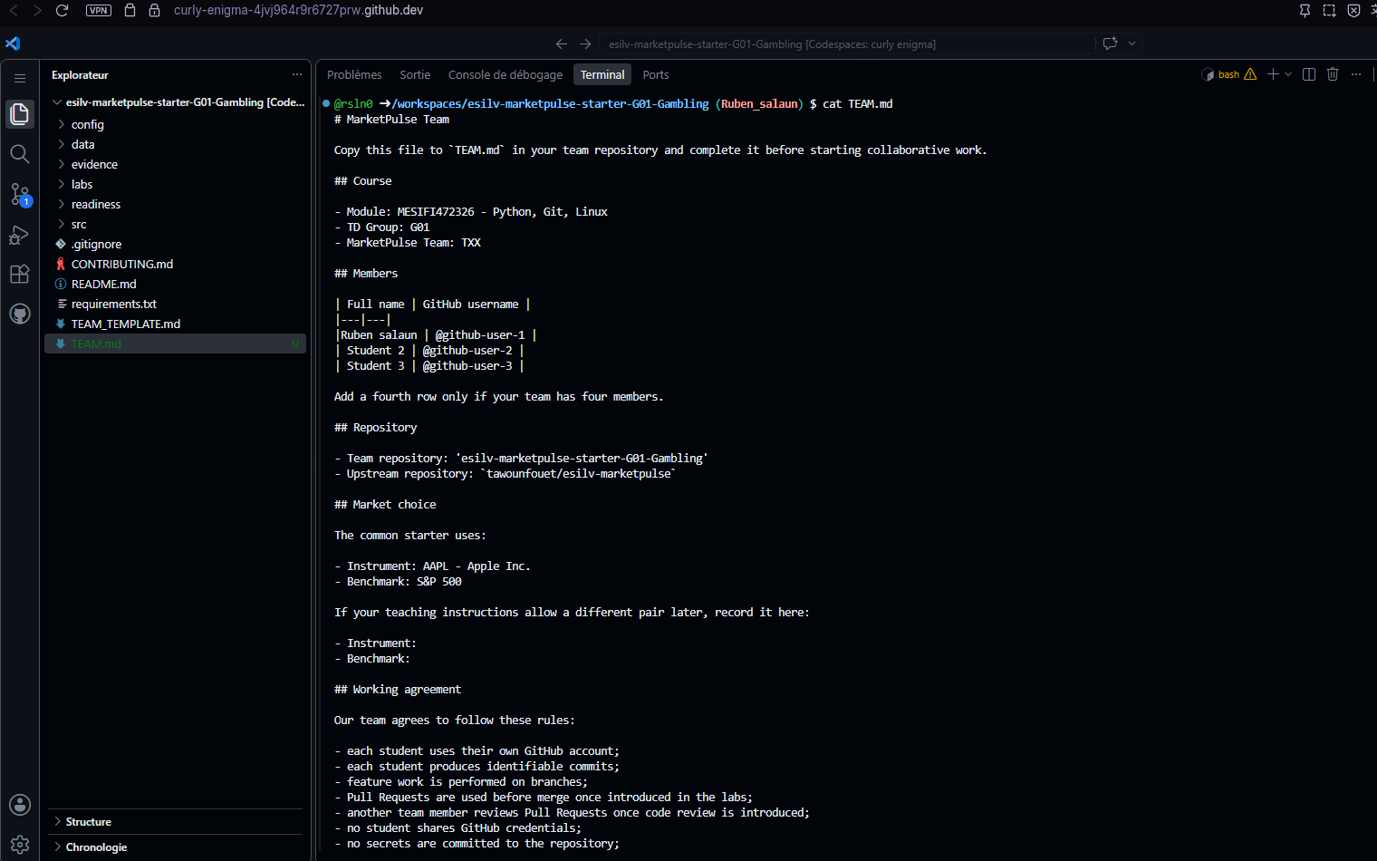
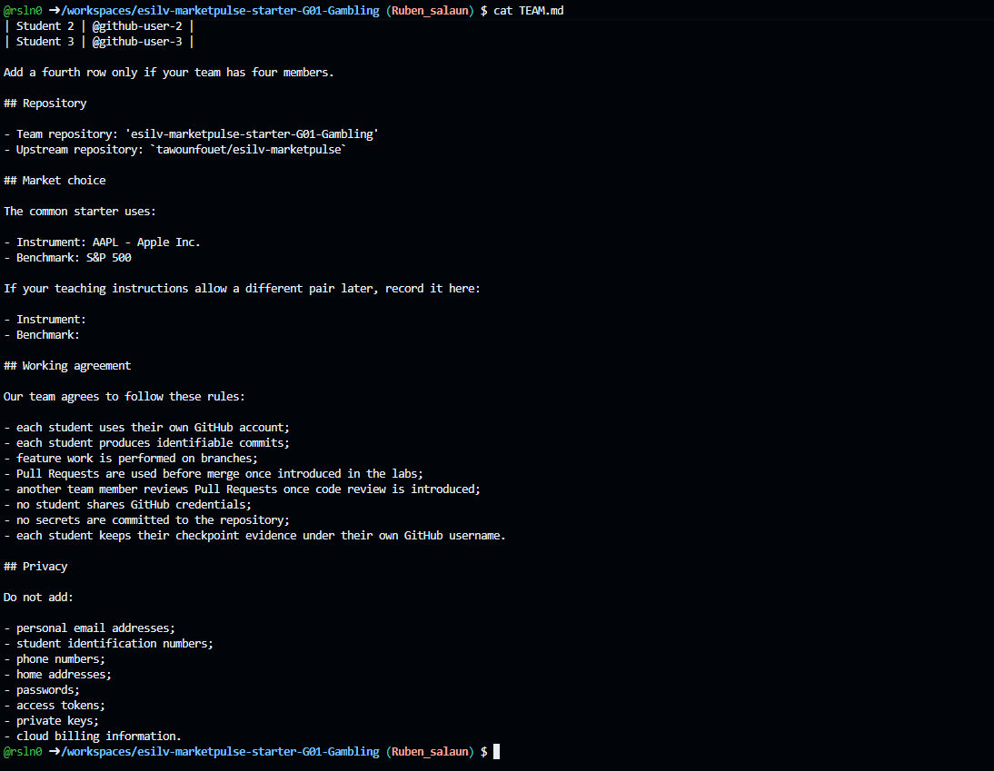

Code TD 2 :
from pathlib import Path
import csv
import json

DATA_DIR = Path("data/sample")

LOOKBACK_LABEL = "1 month"
INTERVAL_LABEL = "Daily"

def load_instruments():
with open(DATA_DIR / "instruments.json", encoding="utf-8") as file:
return json.load(file)

def load_prices():
with open(DATA_DIR / "prices.csv", encoding="utf-8") as file:
return list(csv.DictReader(file))

def filter_prices(prices, ticker):
return [row for row in prices if row["ticker"] == ticker]

def get_first_close(prices):
if not prices:
raise ValueError("No prices available.")
return float(prices[0]["close"])

def get_last_close(prices):
if not prices:
raise ValueError("No prices available.")
return float(prices[-1]["close"])

def display_market_summary(asset, prices, show_currency=True):
first_close = get_first_close(prices)
last_close = get_last_close(prices)

print(f"{asset['ticker']} - {asset['name']}")
print(f"Observations : {len(prices)}")
print(
"First close : "
+ f"{first_close:.2f}"
+ (f" {asset['currency']}" if show_currency else "")
)
print(
"Last close : "
+ f"{last_close:.2f}"
+ (f" {asset['currency']}" if show_currency else "")
)

def main():
instruments = load_instruments()
prices = load_prices()

instrument = instruments["instrument"]
benchmark = instruments["benchmark"]

instrument_prices = filter_prices(prices, instrument["ticker"])
benchmark_prices = filter_prices(prices, benchmark["ticker"])

print("=== MarketPulse ===")
print()
print("Market configuration")
print(f"Period : {LOOKBACK_LABEL}")
print(f"Interval : {INTERVAL_LABEL}")
print()
print("Instrument")
display_market_summary(instrument, instrument_prices)
print()
print("Benchmark")
display_market_summary(benchmark, benchmark_prices)

if __name__ == "__main__":
main()
